
Engineering for everyday world

Ace Engineer
Project Data Flow
GoM Wells

Revision History:

REV | DATE | DESCRIPTION | ORIG | CHK | APPR
01 | 31 Dec 10 | Copied from AceEngineer programming manual 9002-MAN-0002-05 | VA | VK | VA

Change Log

REV | SECTION | CHANGE DESCRIPTION

Document Holds
Hold | DESCRIPTION

CONTENTS
1 Introduction 4
1.1 Document Purpose 4

2 Methodology 4
2.1 Data sources 4
2.1.1 BOEM………………………………………………………………………………………..4

3 Data gathering………………………………………………………………………………4
3.1 Blocks data…………………………………………………………………………………...4
3.1.1 Csv files………………………………………………………………………………………4

4 Data Analysis…………………………………………………………………………………5
4.1 Input…………………………………………………………………………………………..6
4.1.1 Output…………………………………………………………………………………………7
4.2 GIS python……………………………………………………………………………………9
4.3 Resource Evaluation………………………………………………………………………..13
4.4 Flow Chart Analysis………………………………………………………………………...14

introduction

Document Purpose
The purpose of this document is to detail all the basic information of Gulf of Mexico (lower tertiary wells) and provides the methodology of the system and the analysis and modules used for plotting wells geospatially.

Methodology

Summary
The key methodology steps are give below:
- Take data from data sources
- Automate where possible:
  - A standard scheduler can be used to

Data Sources
Data can be obtained from:
- BOEM

BOEM
The Bureau of Ocean Energy Management (BOEM) is an agency within the United States Department of the Interior established in 2010 by secretarial order and its mission is to manage development of U.S. Outer Continental Shelf energy and mineral resources in an environmentally and economically responsible way.

3. Data Gathering
https://www.data.boem.gov/

3.1. Blocks data
http://www.noia.org/wp-content/uploads/2016/08/Deepwater-Gulf-of-Mexico-Report-2014.pdf
https://www.boem.gov/GoM-2011-National-Assessment/

3.1.1. Csv files
Download respective block csv data
https://www.data.bsee.gov/Other/DiscMediaStore/WellData.aspx/

4. Data Analysis
Python scripting for lower tertiary wells

4.1. Input

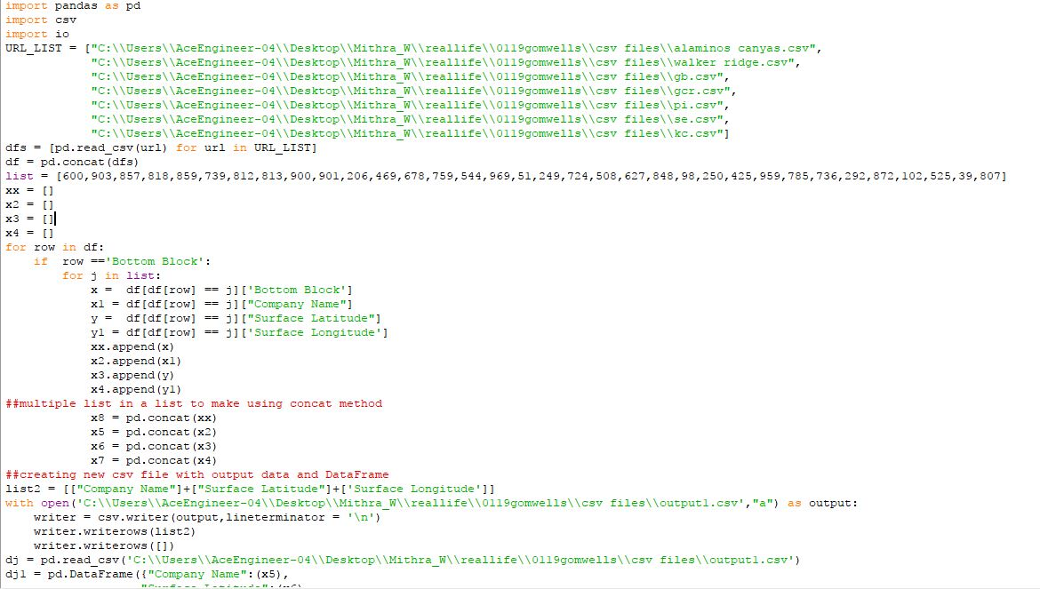

4.1.1. Output

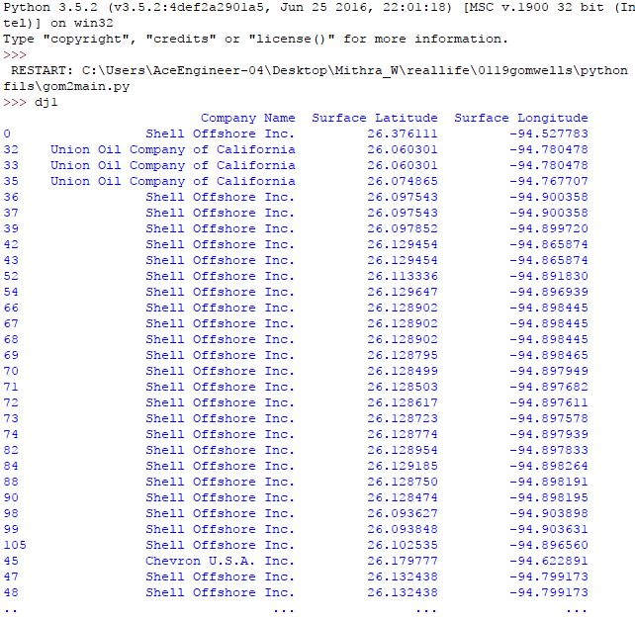

4.2. GIS python
Lower tertiary wells by latitude and longitude analysis by Bokeh module
Python scripting

Reference: https://www.youtube.com/watch?v=P60qokxPPZc/

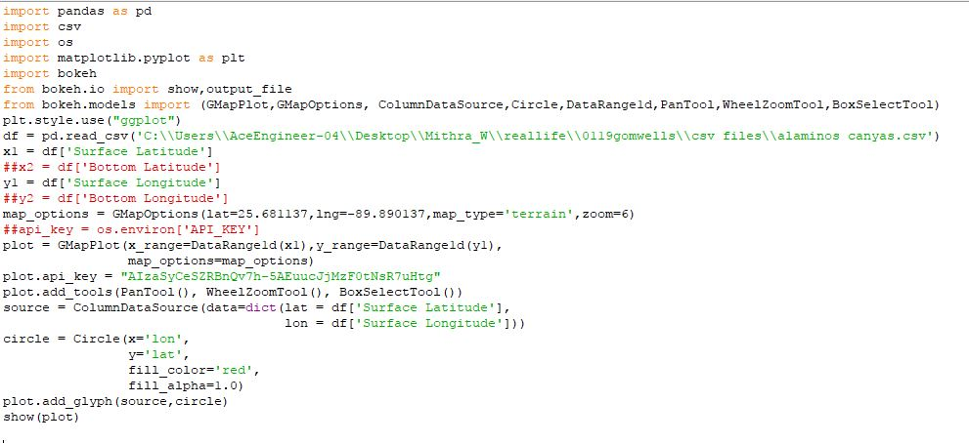

Output

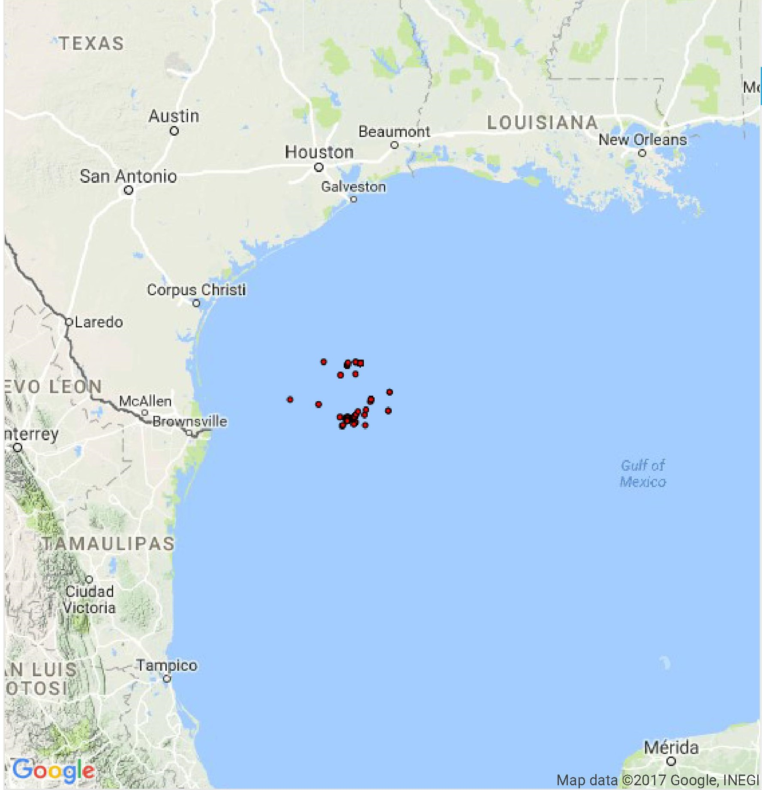

4.2.1. GIS python
Lower tertiary wells by folium module

Python scripting
Reference: https: //georgetsilva.github.io/posts/mapping-points-with-folium/

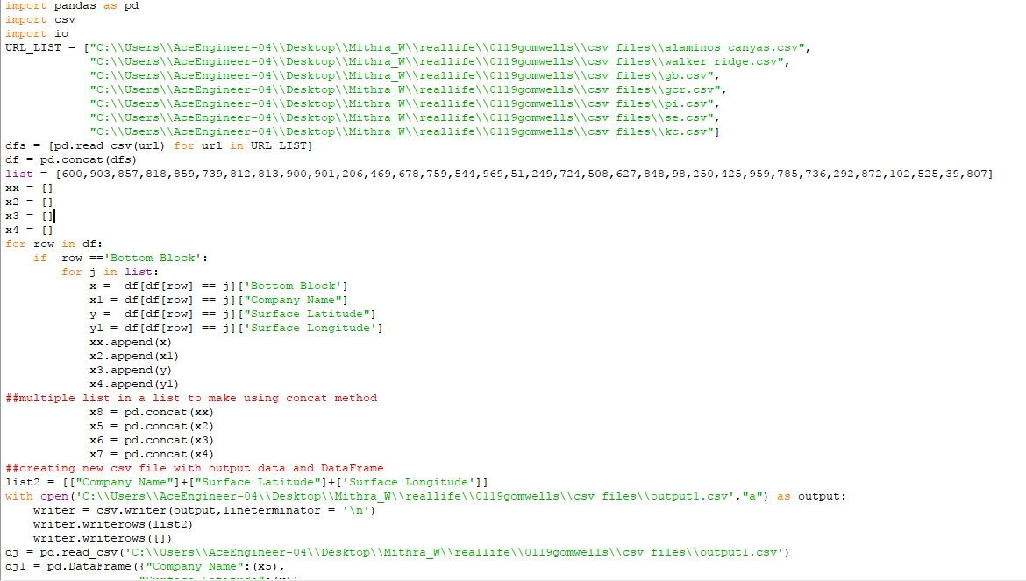

- https://www.youtube.com/watch?v=Yd5oEIBFQ_E
- https://www.youtube.com/watch?v=2u-KFbRX44I

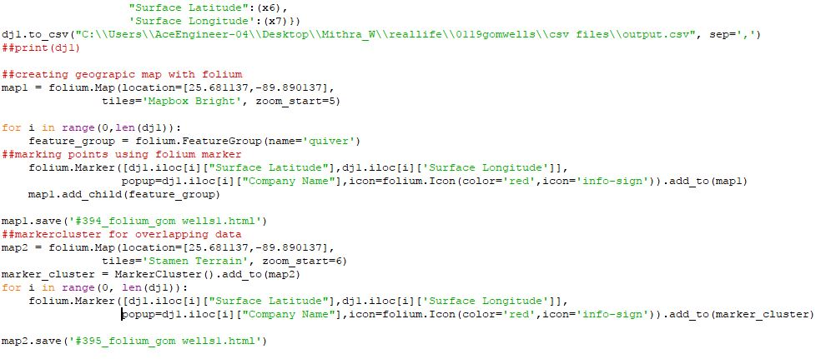

Output1:

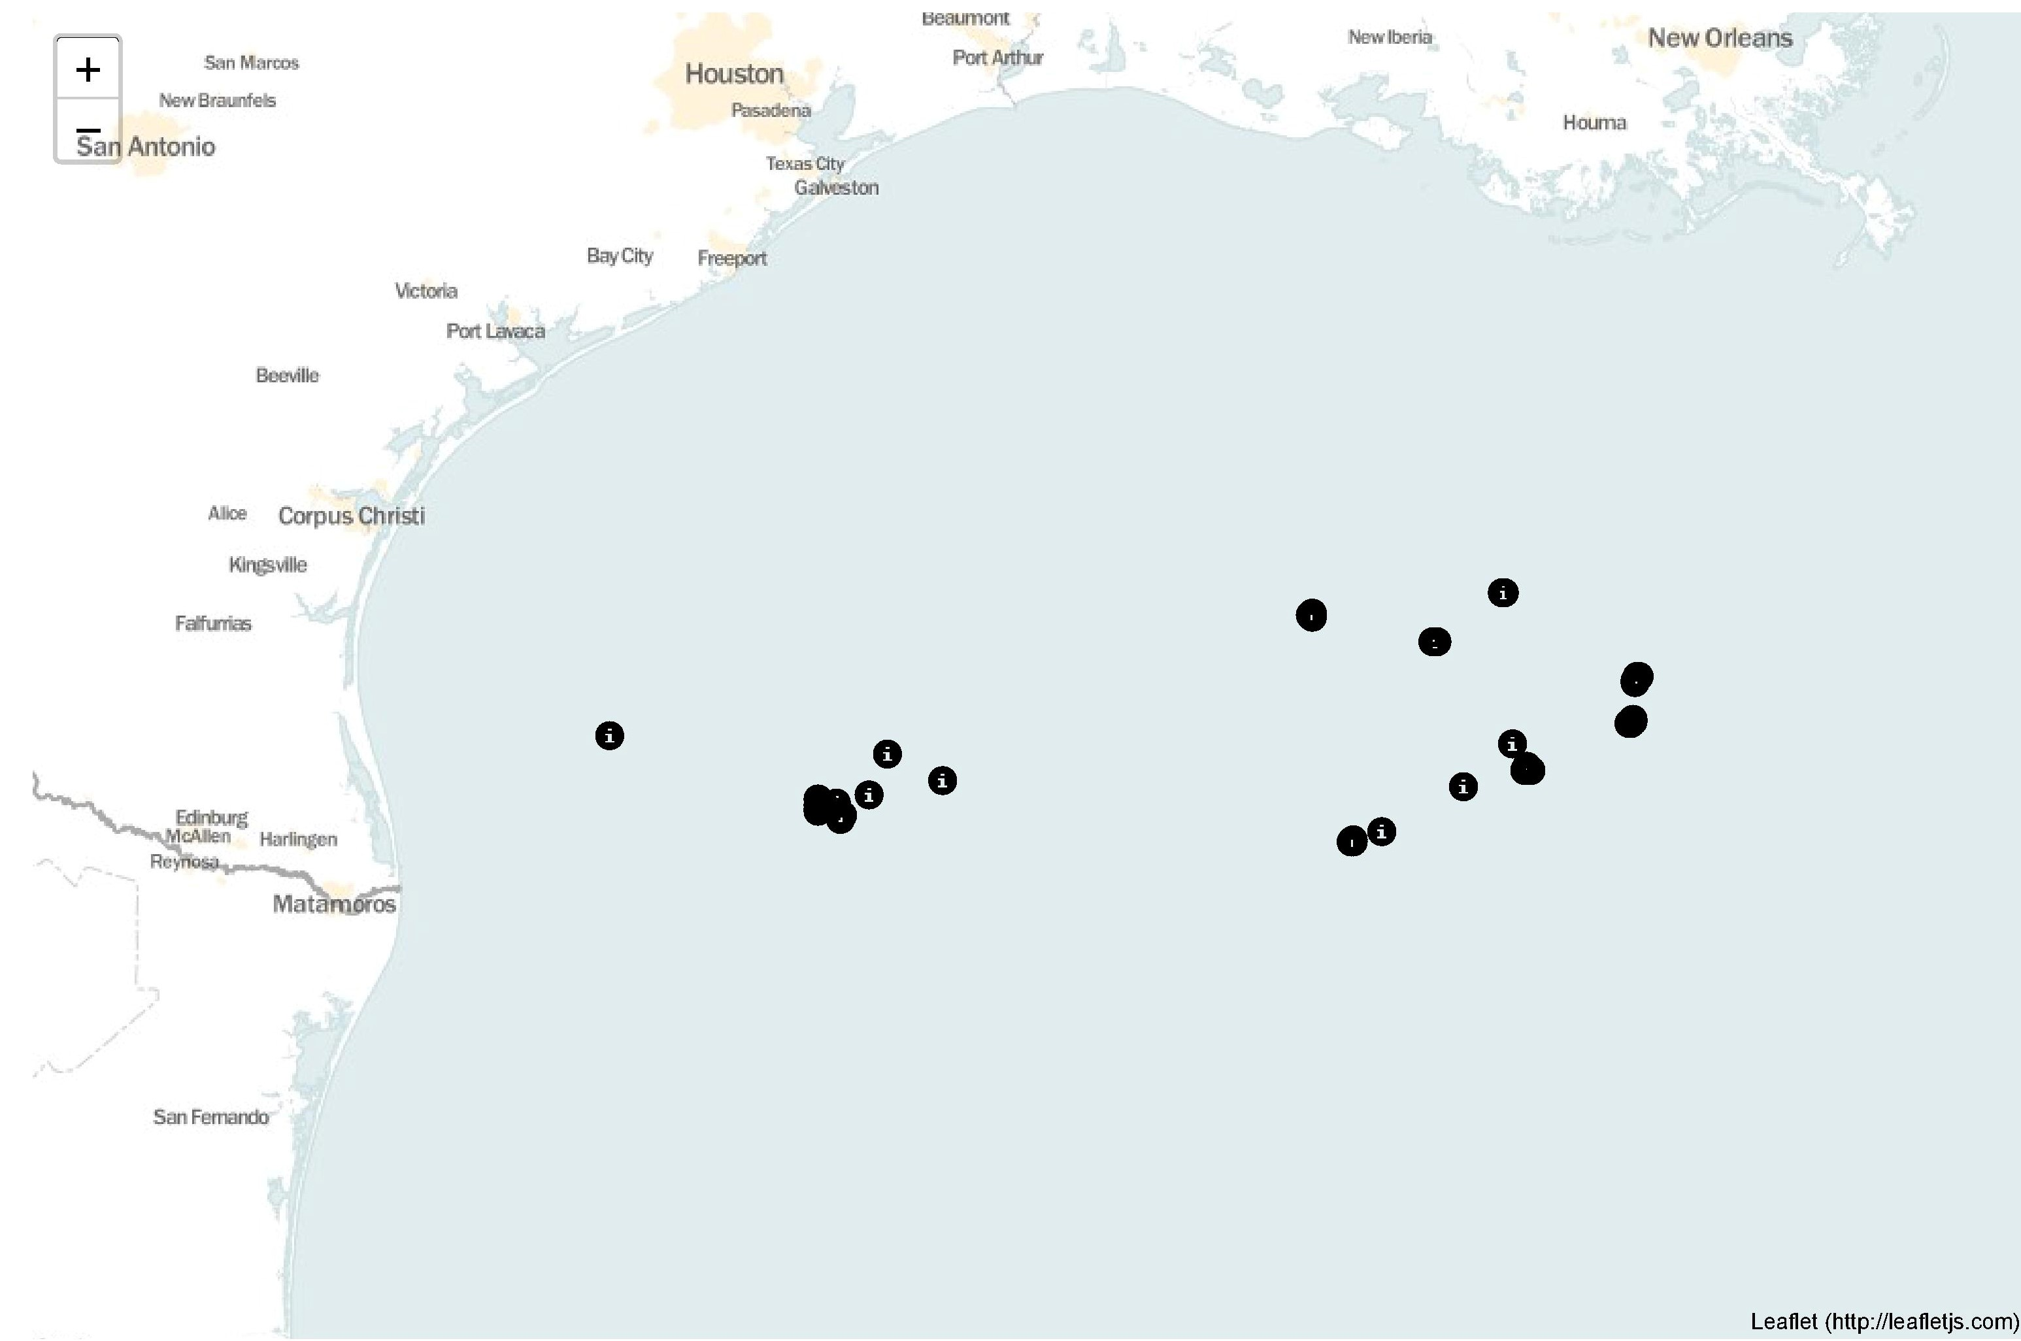

Output2:
Using marker clusters

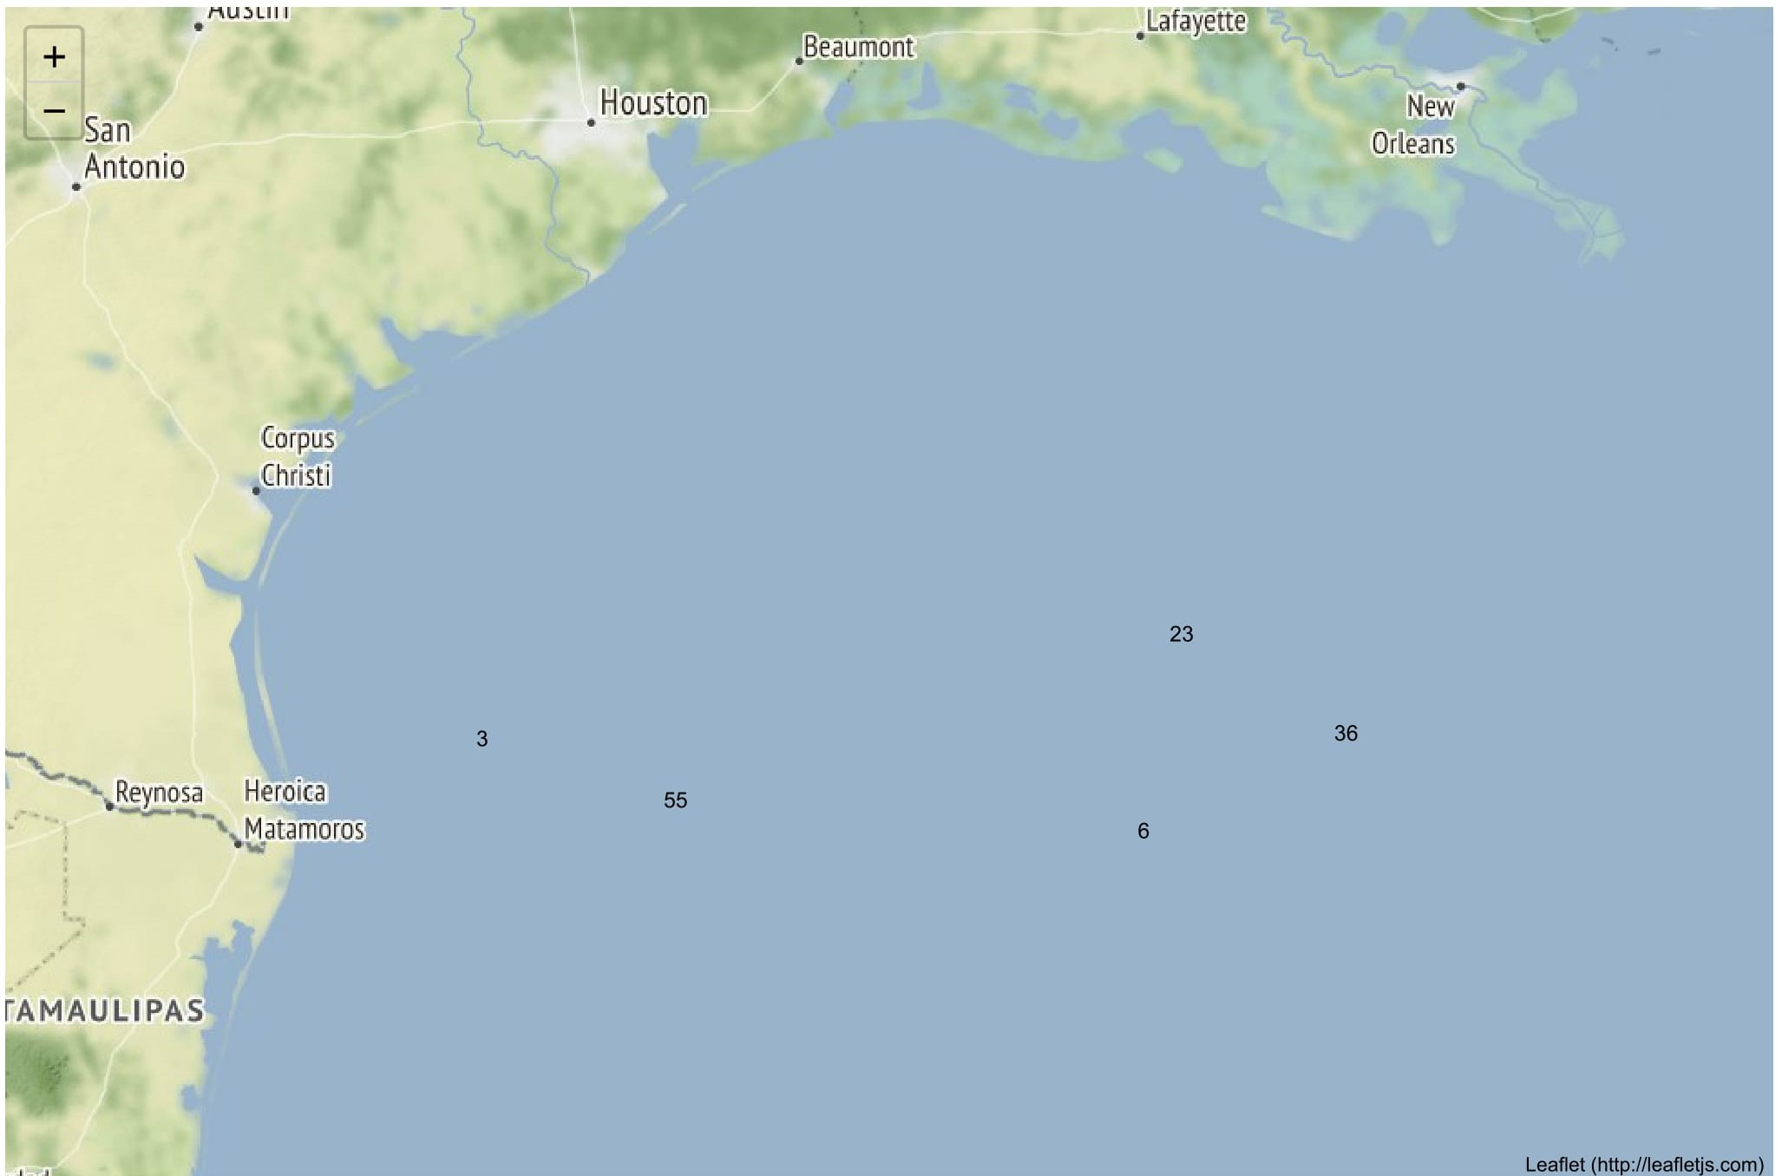

4.3. Resource evaluation (Lower tertiary wells)
Resource evaluation from
https://www.boem.gov/Reserves-Inventory-Program-Gulf-of-Mexico-OCS-Region/

Segregating the reserves by using blocks data.

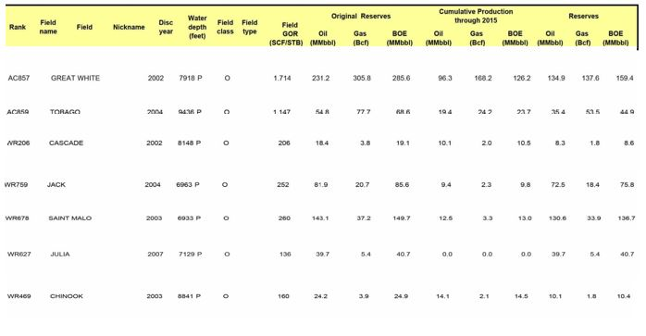

4.4. Flow Chart Analysis

Gulf of Mexico wells
Data flow

https://www.data.bsee.gov/Well/Borehole/Default.aspx

Download Blocks.csv
Data analysis

Python script for sorting Lower tertiary wells by using block numbers

Collection of wells data csv format

http://www.noia.org/wp-content/uploads/2016/08/Deepwater-Gulf-of-Mexico-Report-2014.pdf/

GIS python for lower tertiary wells

Collection of lower tertiary blocks data
Resource classification

